**Reproductive Health and Relationships Education**

**Primary School Package**

These guides are designed to help teachers provide comprehensive reproductive health and relationships education, free from myths, to young people so they will better understand their changing bodies and emotions. The sessions will ideally be divided into a number of educational encounters, to be presented over time. At the beginning of any session, it is important for the teacher to discuss class rules including concepts such as mutual respect between students and consideration of the feelings of fellow students. The teacher should also make children aware that some students may have had experiences they don’t fully understand, so all participants should be allowed to speak without judgement.

Some teachers may feel uncomfortable teaching certain details of reproductive health or they may find some of the information is not in agreement their own views such as contraception, for example. In these situations it is important for the teacher to be aware of their own personal views and not let their views influence the teaching of the basic health information presented in this document. Each child deserves objective information about their bodies and relationships in order to prepare them for the decisions they will need to make in their lives. Research has conclusively found that providing comprehensive reproductive health and relationship information to children and young people has 3 very important benefits: 1) it reduces the likelihood of unwanted or underage pregnancies, 2) it reduces the rates of sexually transmitted diseases, 3) and it makes young people more likely to delay initiation of sexual activity until an older age.

**Objectives**

* Educate young people about healthy relationships.
* Allow young people to ask questions about their bodies, their experiences, and sex in general.
* Educate young people about consent (permission).
* Empower young people to say no to unwanted sex.
* Empower young people to make good choices and be respectful of themselves and others.
* Reduce the risk of sexual assault in young people.
* Empower young people to take control of their own sexual health, including contraception.
* Inform young people about where to seek help if necessary.

**Evidence for sexuality education:**

* **Sexuality education has been shown to reduce sexual activity, sexual risk-taking behaviour and rates of STDs or HIV.**
* **Sexuality education increases people’s knowledge and improves their attitudes about sexual and reproductive health and behaviours.**
* **Abstinence-only education has been found to be INEFFECTIVE in delaying sexual initiation, reducing frequency of sex or reducing the number of sexual partners.**
* **Sexuality education is most effective when school-based programs are combined with community activities such as condom distribution, involvement of parents, and health provider training to deliver youth-friendly services.**

**How this Package is designed:**

The following package contains a collection of topics that should be covered within a child’s school life. Some aspects will have already been covered within other subjects, such as biology.

Many of the topics have suggestions of activities that can be used to make the program interactive for the children. This will help them retain the information, as well as develop interaction skills and independence. Some activities are indicated as more suitable for older children and some are indicated as suitable for younger children.

Each topic has specific Teacher Reference Sheets that contain information for the teacher or counsellor. The information within these sheets is often more in-depth than the children will need to know, but it may help the teacher when answering questions or planning lessons. It is advised that the teacher or counselor read these Reference Sheets before presenting the lesson/session.

The written package is supported by videos produced by Empower Tanzania. These provide information in visual form through animation and film and can be shown within the sessions as appropriate, but should be accompanied by teaching and discussion.

This is specially designed for primary schools. There is a similar package for secondary schools that will include the much of the same content, but more information about STDs, contraception and sexual intercourse.

Student learning builds on the knowledge that the student already possesses and is more than just receiving and processing information transmitted by teachers. Student learn best when they build their understanding by discussion with personal opinions and experiences. Giving students the opportunity to think about their own lives enhances the learning of information received from teachers.

**Relationships**

The goal of the relationships portion of this guide is to teach children that a healthy relationship is:

* **Consensual and non-exploitative**
* **Concerned about consequences such as sexually transmitted diseases (STDs) and pregnancy**
* **Respectful and caring**

**All ages:**

- **Discuss what a relationship is.**

*This discussion should be broad, and include discussion of different types of relationships such as the child’s relationships with parents, friends, and people in town. Pupils should be encouraged to discuss what qualifies a ‘relationship’ and how they feel about themselves when they are with different people. E.g. happy, safe, loved etc.*

- **have children make a list of people they feel safe with in their lives**, making this as personal as possible. For example, my mother, my teacher Mrs. Nzota, my Aunt Rehema. Get each child to write the names of these people down on a piece of paper, and decorate the paper, making it special to them.

*These should not include generalizations, such as teachers, police etc. Try to encourage the children to choose a least one adult in school, and one from outside of school, so they have trusted adults identified as a contact for different parts of their daily lives. The children should be encouraged to keep this list somewhere safe, and to choose someone from this list if they ever feel they need to speak to someone.*

*It may be appropriate to explore and ensure the emotional qualities of the relationships the child writes down to ensure the child is identifying healthy relationships and not just ones that they believe are safe/trusting for possible manipulative/traumatic/guilt/shame reasons: “I trust Uncle Joseph because he tells me we can keep secrets with each other”.*

**Saying ‘No’.**

*At the end of every session, the teacher should ensure that all pupils understand they have the right to say no to anything they do not wish to happen within any relationships, romantic or otherwise. They should never feel forced into anything within a relationship. This includes being ‘pressured’ into doing anything sexual, such as having sex in payment for food, or having sex to keep the relationship. Try to be available for the children after the lesson if they want to talk.*

**Hearing ‘No’.**

*Respect of the opinions or others begins with listening to what they are saying. If someone is telling you no, this means “no”.*

**Teacher Reference Sheet**

**Relationships**

Children learn about relationships from their own experiences. This includes experiences with parents, friends, siblings etc. If children are only subjected to unhealthy relationships, they grow to accept these as ‘healthy’. Unhealthy relationships can vary, from being disrespectful or **uncaring**, to being physically or emotionally **abusive.**

Signs of an unhealthy relationship in a person can be subtle. A young person may become more **withdrawn** in class, more **nervous**, act out in class by causing disruptions and getting into **trouble** when this was not a problem previously with that child. These behaviours may result from relationships in which the child is being **humiliated**, **controlled** or **harmed**, and they can be a cry for help.

An unhealthy relationship can cause a young person to become **isolated** from friends through a partner’s extreme **jealousy**. For example, the young person may not sit with their friends at lunch or avoid interacting in class as they normally would. **Truancy** is a sign that something in the young person’s life is not right – perhaps they are being stopped going to school by someone, being **pressured** to work instead of going to school, or pressured by a partner to spend more time with them. Teachers need to be aware of patterns in absences which may be a sign of child exploitation as severe as human trafficking or prostitution.

Having an adult they can trust may allow the young person to **speak freely** about their relationships **and feel safe** in doing so. There are some things that a teacher cannot help, such as a family’s financial struggles, but listening to the young person is important, as is providing them with a space to be themselves.

**Touch and Personal Space**

*It is important to discuss ‘good’ and ‘bad’ touch. Explain to children that touch can be good, bad or unwanted.*

‘Good’ touch should make you feel positive e.g. hugs and kisses from family members or friends.

**ACTIVITY. Aimed at 5+**

1. **Make 3 columns on the board. Put a heading in each column including ‘Good’ ‘Unwanted’ and ‘Bad’.**
2. **Ask the children to shout out ideas for touches that should make them feel good and positive. Write these on the board**

*Discuss different situations where touch is a positive interaction. Examples might be parents showing affection such as hugs, kisses and cuddles, someone holding your hand to keep you safe while you cross the road, or a doctor or nurse touching you if you are ill or hurt.*

1. **Next ask children to shout out ideas of touches that may not feel good, but are necessary (‘good but unwanted touch’). Write these on the board under ‘unwanted’**

*Discuss why people may need to touch you in ways that don’t feel good. Examples include grabbing you to stop you running into the road, an examination by a doctor or nurse, or being forced to take medicine or injections. Here you can introduce the idea that a doctor or a nurse may need to see their ‘private areas’, but reinforce the doctor or nurse should ALWAYS* *explain why. In addition, the child should always be able to ask for a trusted adult or a same-gender healthcare provider to be present. Emphasize that children can say no, and should not be asked to keep any secrets from trusted adults.*

1. **Finally ask the children to shout out examples of ‘bad’ touch.**

*This can include hitting, kicking, pinching, or touching a person’s ‘private area’ without medical or hygiene reasons. Again, reinforce that NO child should be asked to keep a secret from their trusted adults or from ANY adults*. *Manipulative adults may find a way to make the child feel good about the secret, but this doesn’t make it ok! If they are being asked to keep secrets, and don’t understand why, then they should talk to someone on their ‘trust list’.* *It may be helpful to discuss “acceptable secrets” with the children and identify which types of secrets are okay to keep (“Don’t tell Auntie we got her this gift today so that tomorrow it will be a surprise!”).*

*It is important to note that “getting permission” from a child is NOT consent because a child is not able to consent to touch in private areas. There is no reason they should ever be touched in private areas by an adult unless it’s for medical treatment or cleaning purposes .*

*See next page for example.*

Example:

**Good Touch**

Hugs from family

Hugs from friends

Kisses from parents

High-Fives/Fist bumps

Holding hands

Carrying a sibling

Breast feeding

**Unwanted Touch**

Vaccinations

Being forced to take medicines

Mama grabbing me to stop me running into the road or a fire.

Washing an injury

Bathing a young child

**Bad Touch**

Hitting

Kicking

Pinching

Touching someone’s ‘private’ areas without medical or hygiene need

**Negotiating and Saying ‘No**

There are many reasons why saying ‘no’ may be difficult. Saying ‘no’ effectively is a useful skill not just for sexual situations, but for life in general. There will be times in every person’s life when they have been asked to do something, maybe at work, or by a friend, that they want to say “no” to.

* **Discuss with the class:** When have you said no? When have others said no to you? Do you feel you always have the choice to say no? Have you ever found it difficult to say no? In what circumstances was it difficult?

There are four elements to saying no effectively:

• Intention – to mean ‘no’

• Body language – for your body to be saying ‘no’

• Words – to say ‘no’ clearly

• Tone of voice – to sound like you mean ‘no’.

**Activity – Negotiating in role play – All Ages**

1. Have the children identify a few scenarios where they really want to say no, for example a sibling wanting to borrow clothes, or a friend wanting to copy homework answers. Write these scenarios on a board. Split the children into groups.
2. Give 2 groups the same scenario, such as copying homework answers.
3. Group one will try to persuade the other group to allow them to copy the homework.
4. The other group will resist and be the ones saying “no”.
5. Have them argue for a while. When you feel there has been enough, have all the children sit down and identify the effective ways of saying “no” that they witnessed.

This may include, having eye contact, being clear when they spoke, good posture. Write these effective ways on the board. It is also good to draw attention to the different ways of saying “no” – firmly (needed in serious situations); nicely/politely (needed in everyday situations such as being in shops); and a negotiated/compromised “no” (needed in friendships, work and sometimes relationships).

**Reproductive Anatomy**

Next, it is important for children and young people to understand their bodies. Boys and girls should learn about their genitals and those of the opposite sex. The essential anatomical parts that all children must know are: the **penis, testicles, vagina, uterus, ovaries, fallopian tubes and genitals.**

**Female Reproductive Anatomy**

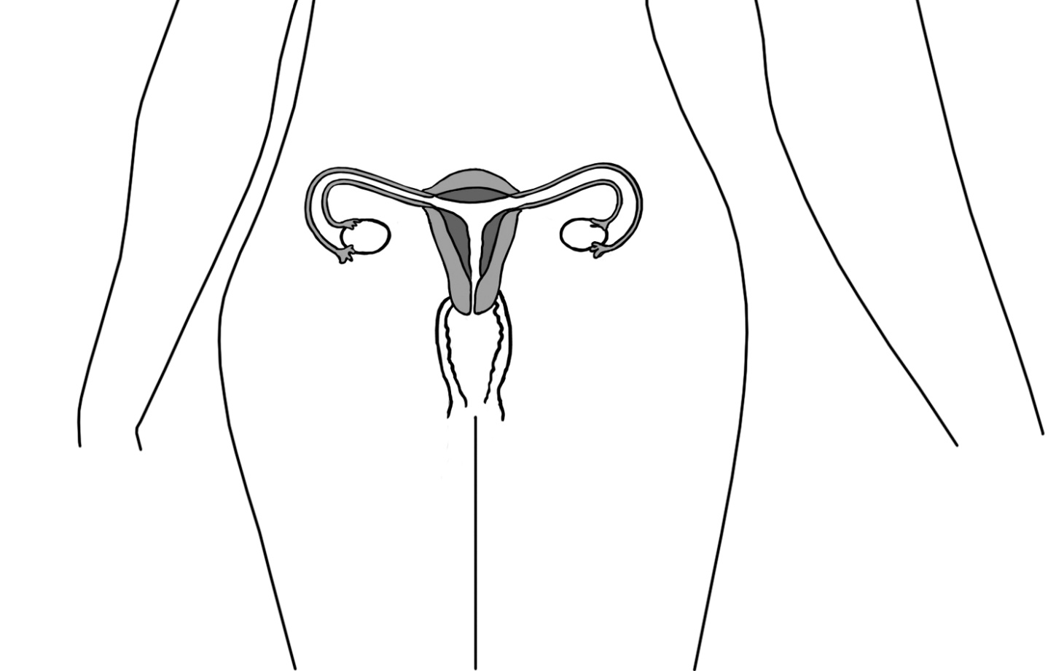

**Fallopian tube**

**Fallopian tube**

**Ovary**

**Ovary**

**Vagina**

**Uterus**

**Cervix**

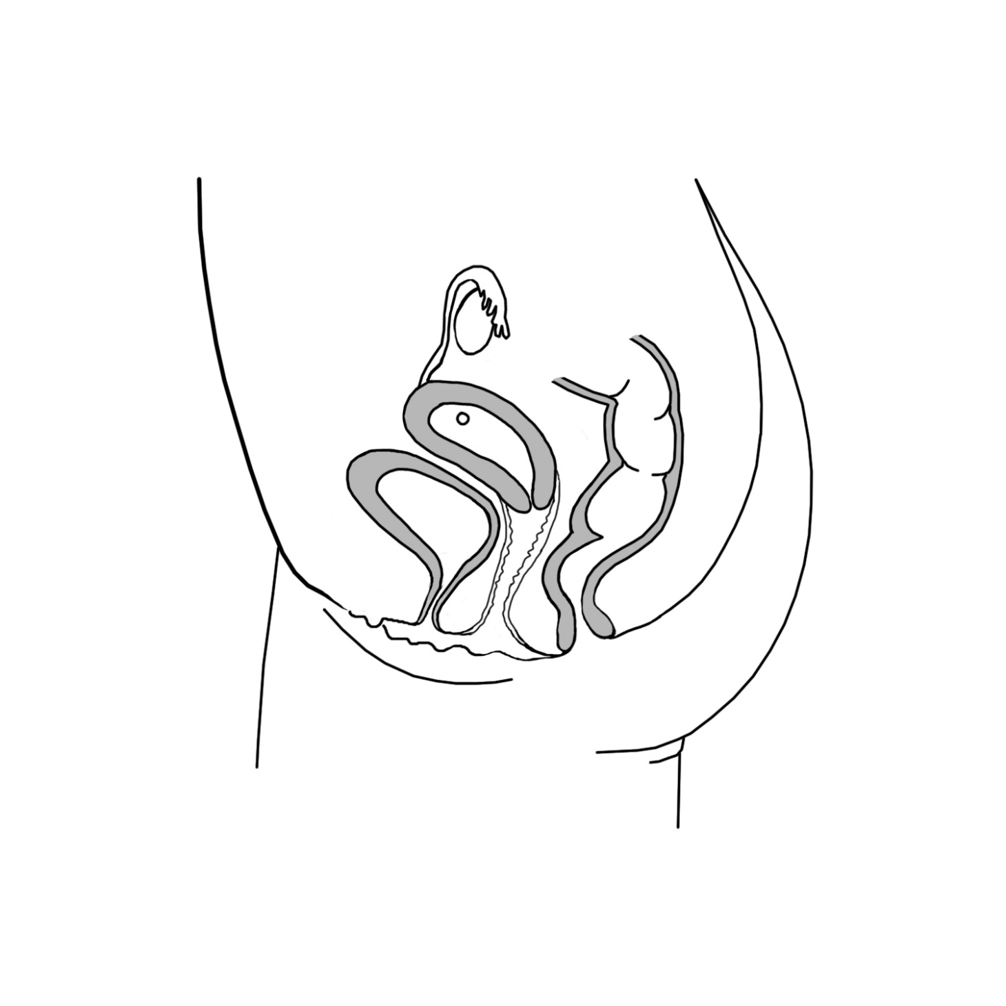

**Bladder**

**Fallopian Tube**

**Ovary**

**Uterus**

**Cervix**

**Rectum**

**Anus**

**Vagina**

**Urethra**

**Labia**

**Clitoris**

**Reproductive Anatomy Organs and Functions**

**Teacher Reference Sheet**

This sheet provides more information than young children need to know in a normal lesson. However, it is provided for teachers to help answer any questions young people may have.

**FEMALE ANATOMY**

**Genitals**

Genitals is the word used for the external part of the reproductive system in both males and females. In females, this term refers to the labia, which are folds of skin located between the legs and at the outer opening of the vagina and the clitoris, a small bump at the front of the labia that provides sexual sensation.

**Vagina**  
The vagina is the canal leading from the labia to the uterus. It is also called the birth canal because a baby passes through the vagina when it is born. The average vaginal canal is 6-10 centimeters long, and is a flattened tube with its walls touching each other. The vagina has great elasticity and can allow a fully developed fetus to pass from the uterus to outside the body of the mother. During menstruation, the menstrual flow exits the body through the vagina.

**Clitoris**

The clitoris is a small female sex organ located in front of the vagina and urethra. The clitoris provides sexual sensitivity.

**Ovaries**  
Ovaries are a pair of small glands about the size and shape of a large grape located on the left and right sides of the upper uterus. They are connected by fallopian tubes. Ovaries produce the female sex hormones estrogen and progesterone that help girls develop into women. They also produce ova, which are commonly called eggs. Eggs slowly develop throughout girl’s early life and reach maturity after puberty. Each month during ovulation, a mature egg is released. The egg travels from the ovary to the fallopian tube, where it may be fertilized before reaching the uterus.

**Fallopian Tubes**  
Fallopian tubes are a pair thin tubes that extend from the ovaries to the uterus. The fallopian tubes begin in a funnel-shaped structure called the **infundibulum**, which is covered with small finger-like projections called **fimbriae**. The [fimbriae](http://www.innerbody.com/image_repo04/repo32.html) pass over the outside of the ovaries to pick up released eggs and carry them into the infundibulum and fallopian tubes for transport to the uterus. The inside of each fallopian tube is covered in cilia that work with the smooth muscle of the tube to carry the ovum to the uterus.

**Uterus**  
The uterus is a hollow, muscular, organ located near the urinary bladder that has a somewhat triangular shape. It is connected to the two fallopian tubes on its upper end, and to the vagina (via the [cervix](http://www.innerbody.com/image_repfov/repo37-new.html)) on its lower end. The uterus is also known as the womb, as it surrounds and supports the developing fetus during pregnancy. The inner lining of the uterus, known as the [endometrium](http://www.innerbody.com/image_repo04/repo34.html), provides nutrition support to the embryo during early development. The muscles of the uterus contract during childbirth to push the fetus out through the vagina at the time of birth.

Each month the endometrium of the uterus thickens in preparation for a fertilized egg. If a fertilized egg does not arrive, the thickened uterus tissue and blood pass out of the vagina during menstruation or “the period”.

**Cervix**The cervix is the lower part of the uterus that opens into the vagina. During childbirth, the cervix expands about 10cm so a baby can pass out of the uterus. The cervix is sealed shut during pregnancy to protect the fetus.

**Bladder, urethra, anus**  
These are not reproductive organs, but are located in the same area. The bladder is a muscular sac that stores urine until it is released through the urethra when we urinate or pee. The opening of the urethra is located in front of the vagina and between the labia. The anus is the opening that passes feces, or poop, out of the body. It is located behind the vagina.

**Male Reproductive Anatomy**

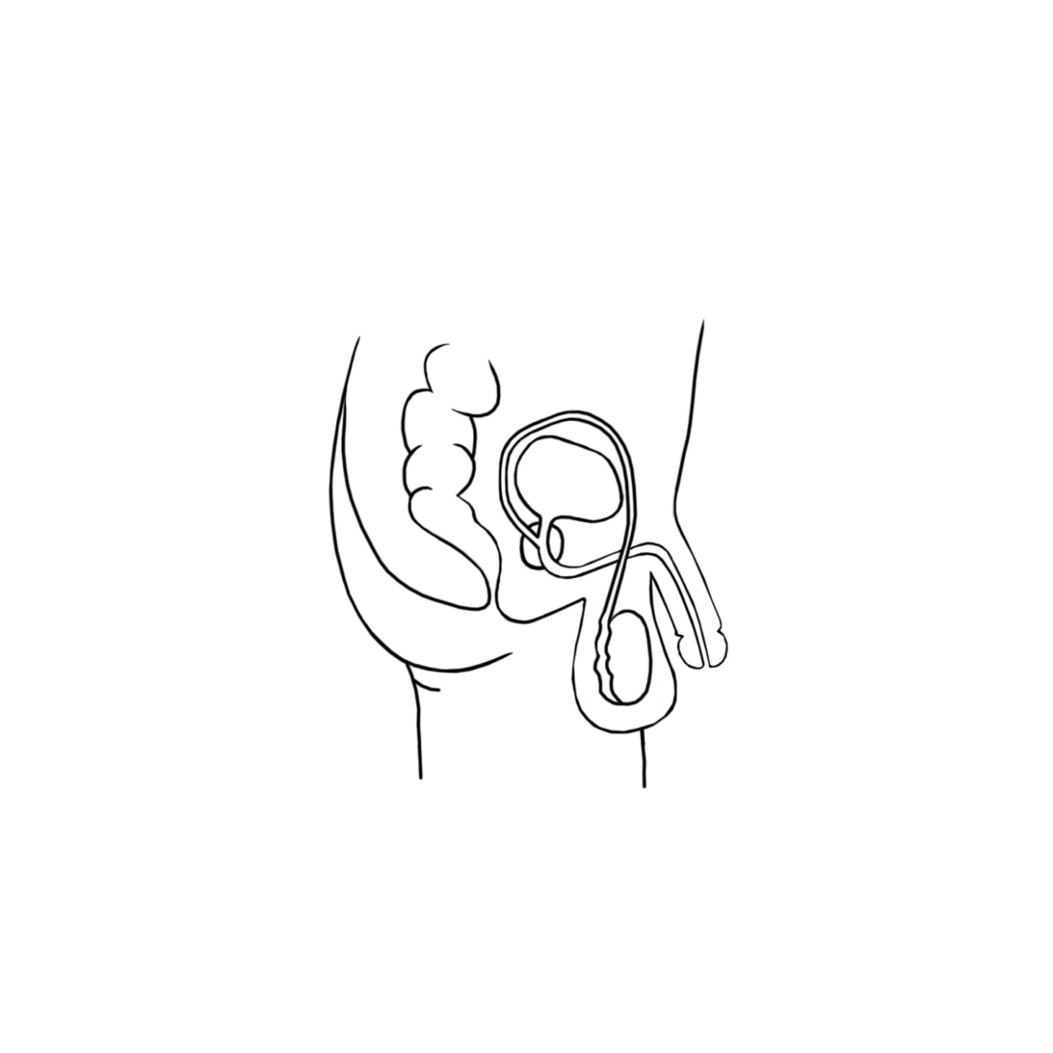

**Penis**

**Urethra**

**Bladder**

**Prostate**

**Rectum**

**Anus**

**Vas deferens**

**Testicle**

**Scrotum**

**Male Anatomy**

**Genitals**

Genitals is the word used for the external part of the reproductive system in both males and females. In males, genitals refers to the penis and the scrotum, the skin sac below the penis that contains the testicles.

**Penis**  
The penis is made of two parts: the shaft (the main part) and the glans (the tip). The penis is made of fibrous tissue, nerves, blood vessels and spongy tissue. It delivers sperm and urine through the urethra. When the spongy tissue in the penis fills with blood, it becomes firm.

**Scrotum**  
The scrotum is a sac-like organ made of skin and muscles that holds the testicles. When the testicles become too warm to support making sperm, the scrotum relaxes to move the testes away from the body’s heat. If the testicles become too cold for sperm to develop, the scrotum contracts to move the testes closer to the body’s core heat.

**Testicles**  
The two testicles are the male organs responsible for the production of sperm and testosterone. The testicles are small, oval, glandular organs. Each testicle is found inside its own pouch on each side of the scrotum. The inside of the testicles contain many special cells that divide and form sperm cells through the process of spermatogenesis.

**Epididymis**  
The [epididymis](http://www.innerbody.com/image_repo02/repo17.html) is a sperm storage area that wraps around the edge of the testicles. The epididymis is made up of several feet of long, thin tubes that are tightly coiled into a small mass. Sperm produced in the testicles moves into the epididymis to mature before being passed on through the [male reproductive organs](http://www.innerbody.com/image/dige05.html).

**Bladder**  
The bladder is a muscular sac that stores urine until it is released through the urethra.

**Prostate Gland**  
A small gland that surrounds a portion of the urethra and produces some of the fluid in semen.

**Vas Deferens**  
Vas deferens are thin muscular tubes that transport sperm from the epididymis of each testicle to the urethra.

**Urethra**  
 This is a tube that carries semen and urine out of the penis in males.

**Starter Anatomy Activity**

**This can be less in depth for younger children, and more in-depth for older children. All children must be taught the proper names for the genitals.**

1. Have children separate into small groups.
2. Have each group gather around a drawing of an entire body on a large piece of paper
3. Have the group label as many parts of body as they can, including eyes, nose, limbs and genitals (penis, scrotum, labia). Encourage them to label genitals even if they are not sure of the correct names. Also ask them to write the function of the body part if they know it, for example – legs for walking
4. Stick all diagrams on the board and correct any inaccuracies. It is very important to teach children to correct names for genitals including penis, scrotum, testicles, labia and vagina. This gives them the ability to speak about that area if they should ever need to. (There may be some laughter when mentioning the proper names. To help alleviate giggles, remind them that these are the names that are used by healthcare providers, scientists and farmers, because many mammals have similar body parts with the same names. Part of growing up is to be mature enough to have these kinds of conversations without giggles.)
5. Next ask the children to identify which areas of the body are ‘private’. Private areas are the parts which we usually keep covered, and which require our permission for someone else to touch.

Alternative Activity

1. Have a large picture of a male and a large picture of a female on the chalkboard.
2. Have some cards with the body parts written on them.
3. Point to a part of the body and ask the children to volunteer to label it using the cards. This should include the whole body, including arms, legs etc. Ask the children what that body part does, for example, legs for walking, mouth for eating and drinking, ears for hearing.
4. Eventually get to the genital area. Young people must be encouraged to use the appropriate names for the ‘private area’ i.e. genitals, penis, scrotum, labia, vagina.
5. The children should then identify which areas of the body are ‘private’.

**Anatomy Activity – Aimed at ages 10+**

This can be done in class or as homework. Print out.

1. Check The box that correctly identifies who had each part
2. Put the letter from the list that describes each part

|  |  |  |  |  |
| --- | --- | --- | --- | --- |
| Body Part | ONLY BOYS HAVE THIS | ONLY GIRLS HAVE THIS | EVERYONE HAS THIS | DESCRIPTION OF FUNCTION (FROM LIST) |
| 1. Urethra |  |  |  |  |
| 1. Penis |  |  |  |  |
| 1. Testicles |  |  |  |  |
| 1. Fallopian tube |  |  |  |  |
| 1. Scrotum |  |  |  |  |
| 1. Vagina |  |  |  |  |
| 1. Anus |  |  |  |  |
| 1. Genitals |  |  |  |  |
| 1. Ovaries |  |  |  |  |
| 1. Bladder |  |  |  |  |

**Descriptions and Functions:**

a. Carries urine from the bladder to the outside of the body.

b. Two small round organs that produce sperm, which are needed to make a baby.

c. Opening where solid waste (feces or poop) leaves the body.

d. The reproductive system parts on the outside of the body.

e. The organ that stores urine (pee).

f. Store the eggs (ova).

g. Connects the ovaries to the uterus.

h. The passageway from the uterus to outside the body. A baby goes through this tube when it is time to be born.

i. Male external body part that contains the urethra. Urine passes through the urethra in this organ and, in grown males, sperm passes through to leave the body.

j. Pouch of skin that holds the testicles.

**Correct Answers – Teacher’s Copy**

|  |  |  |  |  |
| --- | --- | --- | --- | --- |
| Body Part | ONLY BOYS HAVE THIS | ONLY GIRLS HAVE THIS | EVERYONE HAS THIS | DESCRIPTION OF FUNCTION (FROM LIST) |
| 1. Urethra |  |  | X | A |
| 1. Penis | X |  |  | I |
| 1. Testicles | X |  |  | B |
| 1. Fallopian tube |  | X |  | G |
| 1. Scrotum | X |  |  | J |
| 1. Vagina |  | X |  | H |
| 1. Anus |  |  | X | C |
| 1. Genitals |  |  | X | D |
| 1. Ovaries |  | X |  | F |
| 1. Bladder |  |  | X | E |

**Puberty**

* **Discuss puberty. The discussions may be best done in groups separated by gender. However, all topics, including menstrual periods, should be discussed by both gender groups for improved understanding of all aspects of puberty in boys and girls.**

*The Empower Tanzania puberty video is a good introduction to the topic. A separate Empower Tanzania video explains periods in more depth and can be used for girls as well as boys. This should ideally be taught by a female teacher to enable the girls to feel more comfortable asking questions. Please discuss sanitary product options such as reusable menstrual pads, disposable menstrual pads and tampons. Ideally, it is helpful to show the girls examples of each.*

* **Discuss the emotions involved in puberty**. These should include mood swings, feeling worried, and feeling attraction towards others. Severe facial pimples and oily skin occurring during puberty or menstrual cycles may lead to self-consciousness in boys and girls.

*Here it is important to talk openly about these feelings with the emphasis on them being normal and healthy. However, it is important to highlight that feeling attraction towards others does not mean they are ready for a relationship.*

**Puberty and Periods**

**Activity – Anonymous Questions – for all ages**

1. Give each child a small piece of paper.
2. Ask them to write a question on that paper. If they have no questions, then they should write ‘no questions’ so no one knows who asked the questions.
3. Have the children put them in a hat/box/other container.
4. Promise to answer the questions in the next session and ensure this happens. This gives the teacher time to consider the answers to the questions before answering.

**Puberty Activity – Writing Letters- Age 10+**

The aim of this activity to is check the children’s’ understanding of puberty and periods.

Have the children imagine they have received a letter from a younger person asking certain questions. They then have to write a letter back. The letters should be marked by a teacher based on the information given in it, with any inaccuracies corrected. They should also gain praise for being supportive in their letters.

Example of letters are:

Dear Helper,

I am feeling a bit confused and worried. I found a bit of blood in my underwear today. I don’t think I hurt myself, so I’m not sure what it is. Some girls at school said something about a period, but I don’t know what that is. Should I see a doctor? Is there something wrong with me? Please help.

From Catherine

Dear Helper

I have heard from my Mum about something called ‘puberty’ but I’m too embarrassed to ask her what happens. What is puberty and what happens? Does it have to happen?

From Joseph

**Teacher Reference Sheet**

**Puberty**

**Puberty-** This is the period of life during which children’s bodies change to become sexually mature and they become physically capable of reproduction.

**Age**

Girls usually start puberty between the ages of 8 to 13. Some are earlier, some are later. Boys start a little later, anywhere between 9 and 15. Boys may continue to grow until they are 18 or even later. Once puberty is done, girls and boys will not grow any taller. The changes of puberty usually take about 4 years to occur but it varies a lot. Some people are done with puberty by 17 and others may be over 20 before all the changes have occurred. The thing to remember is that each person is different, and their body will go through puberty at a pace that works for them.

**Changes – Both boys and girls**

Hormones are released by the testicles in boys and the ovaries in girls. This happens after the brain releases hormones at the start of puberty. The male hormone responsible for the changes is called testosterone, and the female hormone is called estrogen.

During puberty, people will find they sweat more and produce a different type of sweat that can mix with microbes in the air to cause smell.

Oils glands in skin produce more oil. The increased oil on the skin can cause acne, particularly on the face and neck. Acne is the word for when parts of the skin become red, sore and sometimes have a small amount of white drainage.

Hair will grow under the arms, around the genitals and on legs.

Mood swings

**Changes – Boys**

* Voice deepens after becoming uneven or ‘breaking’
* Muscles become larger
* The penis and testicles grow
* Sperm is produced in the testicles
* Boys have erections and ‘wet dreams’. This is normal
* Hair grows on the genital area and under the arms. Later it grows on the face, back and chest.

**Changes – Girls**

* Breasts develop. The breasts area may be tender when this is happening
* Hips become wider, and the waist becomes smaller
* Periods start, also called menstruation or menstrual periods
* Hair grows on the legs, genital area and under the arm

**Sex and Reproduction**

There is an Empower Tanzania video called Sexual Health that can help with this session. Children should be provided with this information starting at **10 years old**. This is when many children will have an idea about how babies are made and may have heard incorrect myths or rumours. Accurate information answers the child’s questions, and removes the intrigue of mystery. As mentioned before, providing accurate reproductive health information to children and young people reduces the likelihood of unwanted or underage pregnancies, reduces the rates of sexually transmitted diseases, and makes young people more likely to delay initiation of sexual activity until an older age.

**Children 10+ years old**

* **Discuss the biology of sexual intercourse.**

*This can be done as a biology lesson. It should cover what the act of sexual intercourse is, and how this can make a baby.*

*A good introduction to this topic is discussing animal reproduction, such as dogs, and how the offspring generally resemble the parents, but are not identical. You can then progress to talk about human reproduction, particularly how it involves a man and a woman, the anatomy involved, and how this makes a baby.*

**For older children – Aged 12+**

* **Ask the young people to consider the emotions involved with having sex**.

*This should be an open discussion, including positive aspects, such as feeling loved, feeling happy etc. It can also include feeling worried or anxious, and feeling confused. Allow them to express themselves and reassure them that all these feelings are normal, but should they have any questions or worries, encourage them to speak to an adult.*

*Within a Primary school session, an understanding of sex and reproduction is enough without having to discuss STDs and contraception. However, it is recommended that teachers mention that there are some risks of having sex such as ‘infections’ and having a baby when the mother or father is too young.*

*If any questions are asked, the teacher should answer them fully and honestly. Children may have heard rumours or inaccurate information, so it is important that they receive correct information from the teacher.*

**Teacher Reference**

**Egg**



**Sperm**

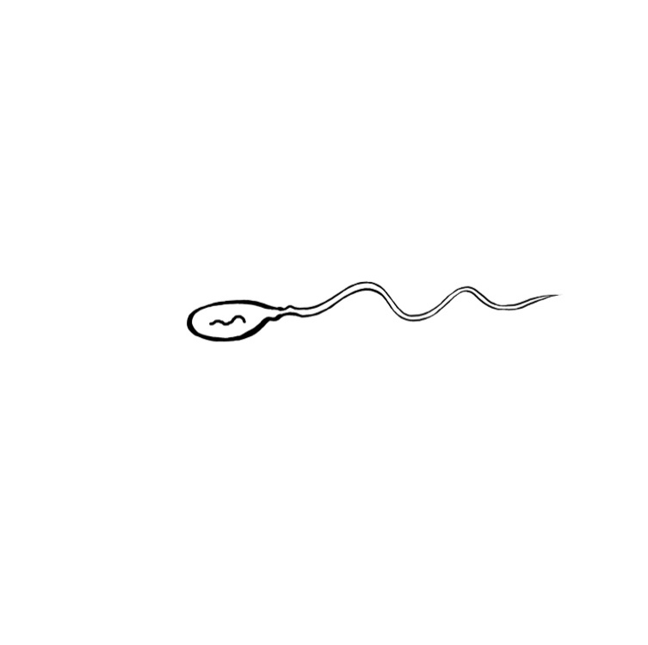

**DNA**

**DNA within nucleus**

Organisms have sex cells called **gametes**. In human beings, the male sex cells are called **sperm**, and the female sex cells are called ova or **eggs**. Each sex cell contains **23 chromosomes**, the genetic information of life. Human beings have **46 chromosomes** in total. This number is achieved by combining the 23 chromosomes from the mother with the 23 chromosomes from the father to complete the 46 chromosomes needed to make a human being. The chromosomes of other animals operate in the same way.

Sexual intercourse refers to the sexual act of an erect penis entering a woman’s vagina. After a while, the penis will release some fluid, called **semen** through a spurting of this fluid, called ejaculation. The semen includes **sperm** with the genetic information from the man and other fluid that provides nutrients for the sperm to move.

If this semen is released inside or even near the vagina, it will swim through the **cervix**, into the **uterus** and along the **fallopian tubes.**

If an egg is in the fallopian tube or in the uterus, the sperm may meet the egg. The egg is usually passing through these areas during days 12-16 of a woman’s menstrual cycle. This is called the fertile period because it is when it is most likely that an egg is in the fallopian tube or uterus. However, it is very possible for an egg to be released during other parts of the menstrual cycle and it is possible to become pregnant if sperm are present during other parts of the menstrual cycle.

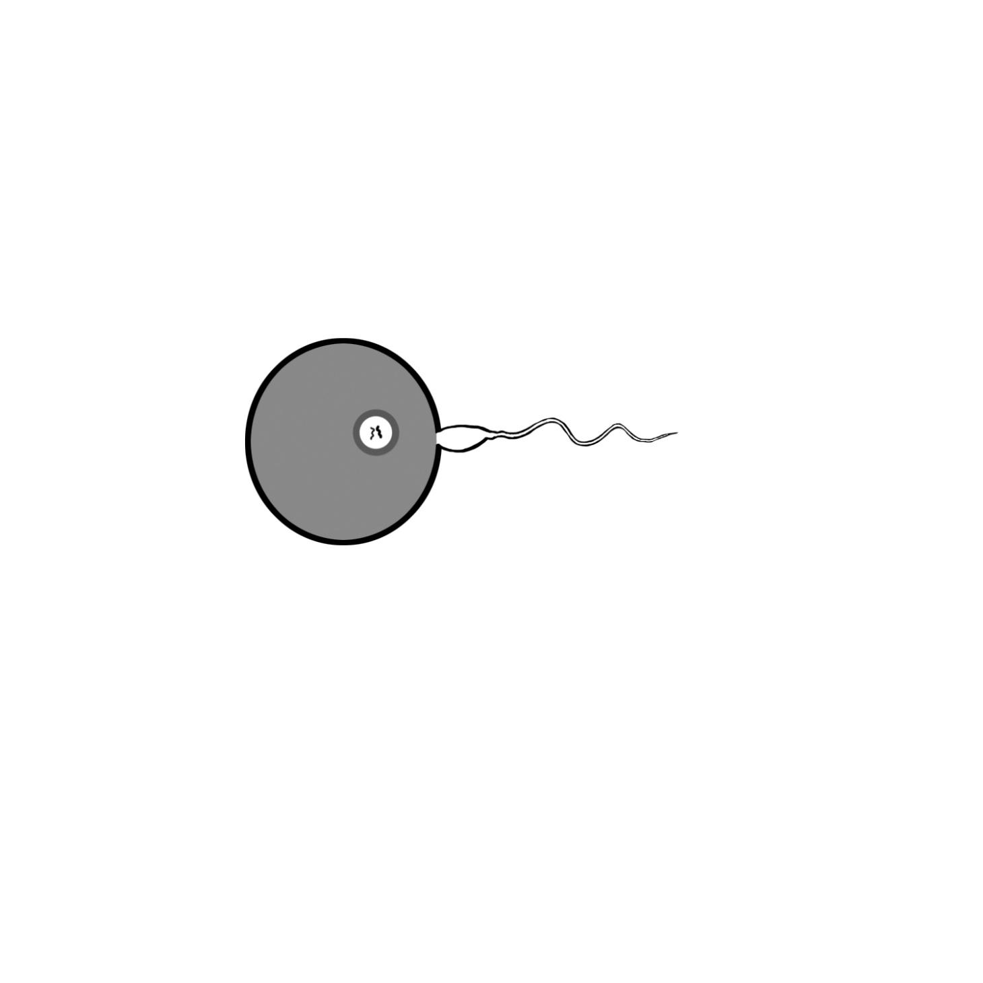

If the meeting of one single sperm with the egg happens, the sperm joins the egg in a process called **fertilization** and their two sets of 23 chromosomes join to make 46 chromosomes. Once this happens the joined egg and sperm is referred to as an embryo. The embryo has **46 chromosomes** in total and is the beginning of a new human being. This mixing of genetic information from each parent in the form of chromosomes is called sexual reproduction. This is why children generally resemble their parents, but the mixing means they are not identical to either parent.

The embryo continues to move along the fallopian tubes towards the uterus, dividing into more cells along the way. Around 7-14 days after sexual intercourse, the embryo attaches itself to the lining of the uterus. This lining is called the endometrium and the attachment of the embryo to the endometrium is called **implantation**. Not all embryos are able to implant.

Once implanted, the cells begin to develop differently. The **placenta** is one of the first parts to develop. The placenta attaches the to the uterine lining and provides continual nutrition to the embryo. The cells now grow at a rapid pace. From around week 8 of the pregnancy, the embryo is called a **fetus**. Within a fetus, the cells specialise and grow to form the major organs, such as the brain, the liver, and the kidneys. Menses stops for the duration of a pregnancy.

**Consent and Sexual Abuse**

* **Explain what consent is**

*For use within primary school, a good introduction is discussing how someone knows if a friend wants a hug. Discuss how some people like hugs, and others do not. Also how some people like hugs from certain people, like family, but not from other people.*

*Explain that if someone gives ‘permission’ for something to happen, then they have given ‘consent’. But it’s not consent if they have been threatened, forced or pressured. It is important to note that “getting permission” from a child is NOT consent because a child is not able to consent to touch in private areas. There is no reason a child should ever be touched in private areas by an adult unless it’s for medical treatment or cleaning purposes.*

*Always reinforce that young people have the right to say no to anyone touching their bodies at ANY age.*

* *Silence is not consent.*
* *“I don’t know” is not consent.*
* *Consent for a kiss does not mean consent for sexual intercourse.*
* *A drunk person or a person on drugs cannot give consent.*
* *“Getting permission” from a child is NOT consent. Anyone under 18-years-old can NOT legally consent to any sexual activity by Tanzanian law.*
* *Consent is not possible with threat, force or pressure.*

*At the time when discussing sexual intercourse and reproduction, it is a good time to talk about the legal age when this can happen. Also, sexual intercourse should never happen if someone does not want it to. Here the word ‘rape’ should be introduced, as well as the legal and social consequences for anyone that forces another person to have sex.*

* **Discuss Sexual Abuse**

*This topic should be done gently, as it is possible that some students may have been previously abused. It is important to emphasise that sexual abuse can be from ANYONE: someone their own age, someone older, someone in a more powerful position, like a teacher. Be emphatic that sexual abuse is never the victim’s fault.*

*Sexual abuse may come in many different forms, such as being physically forced to perform sexual acts against a person’s will, being threatened to perform sexual acts, being pressured, or being harassed. For example, someone on the way to school may say crude and sexual things, or make someone watch sexual things. These are all forms of sexual abuse.*

* **Discuss why sexual abuse may be difficult for the victim to speak about.**

*Ask the students for their thoughts or ideas about why a sexual abuse victim might have difficulty expressing their feelings or telling about the experience to others. Referring to a victim, students may say ‘they may feel embarrassed’; ‘they may feel like it’s their fault’; ‘they may not understand what is happening’; ‘they may feel they have no choice’ ‘they might feel scared if they or their family have been threatened’; ‘they may be scared people will not believe them’.   
After hearing answers from students, discuss these feelings and reassure them that it is always appropriate to tell a trusted person about possible sexual abuse.*

*Reinforce to the students that no one has a right to touch them in ways that makes them feel uncomfortable, or make them do anything they do not want. No one has the right to make another person feel uncomfortable through sexual comments either.*

* **Discuss how a person being abused should talk or otherwise communicate with a trusted adult about their experience or concerns, even if it is difficult for them to do so. This is one of the main reasons why they have identified the trusted adults earlier in this training.**

*Possible ways to communicate with a trusted adult could include: Draw a picture, writing a note, closing your eyes and telling, using a doll or toy to help with the telling, use a doll or toy to do the telling for you so you don’t have to look in their face, using texts or email to tell the trusted adult.*

**Teacher Reference Sheet- Tanzanian Law**

**Consent**

The age of consent within Tanzania is currently 18 years old. This means that any person under the age of 18 cannot legally consent to any sexual activity.

**Statutory Rape**

Statutory rape is the term given for the act of a person over 18 to have sex consensually or otherwise, with a person under 18. The person over the age of 18 can be prosecuted. It is also counted as statutory rape if the consent has been *obtained by the use of force, threats or intimidation or by putting the fear of death or of hurt while she is in unlawful detention. (Penal Code Cap 16 RE: 2002)*The punishment for having sex with a schoolgirl and getting her pregnant is currently up to 30 years imprisonment.

**Marital clauses**

However, this becomes more complicated once married: It *is* lawful for a man to have sexual intercourse with his wife, who may be younger than 18, but must be older than 15. If a wife is over 15 years old, the man does not legally need consent. The Sexual Offence Special Provisions Act (1998) states that:

A male person commits the offence of rape if he has sexual intercourse with a girl or woman under circumstances falling under any of the following descriptions:

* With or without her consent when she is under 18 years of age, unless the woman is his wife who is fifteen or more years of age and is not separated from the man. (Section 5 Rape)

The legal age for a female to be married is 14, with the consent of a court, or 15 with the consent of parents. (Law of Marriages Act 1971). The High Court of Tanzania has stated this will be revised in the near future (July 2016)

**Consent to Contraceptive Services**

There is currently no legal age to consent to medical treatment, which contraceptive services falls under. Due to this absence of legal directives, there is no minimum age for seeking contraceptive advice, and parental permission is not required. Some clinics may wish for parental consent.

**Age for HIV testing**

The age of HIV testing in Tanzania is 16. Adolescents aged 16-17 are considered ‘mature minors’ and can consent for themselves, without parental permission. Below the age of 16, parental permission must be sought. However, if the result is positive, health care practitioners are required to report the result to parents if the adolescent is under 18. If over 18, the person has the right to confidentiality of the results.

**Abortion**

Abortions are illegal within Tanzania unless to save the mother’s life. (Penal code cap 16:2002)

Southern African AIDS Trust (2016) . Age of Consent: Legal Review. Tanzania Country Report. Online. Available childrenandaids.org Accessed 22/09/17

  
  
  
  
  
  
  
  
  
  
  
  
  
  
  
  
  
  
  
  
  
  
  
  
  
  
This program has been written by Empower Tanzania Incorporated. Same. Tanzania.   
Email: [information@empowertz.org](mailto:information@empowertz.org)  
  
Content provided by Jessica Haworth (MNurSci; RN Child) and Jeffrey Carithers, MD, FACS  
2018